Phases of meiosis

1. PROPHASE I | Chromatin threads condense to form chromosomes – maternal and paternal homologous chromosomes are attracted to each other and pair up (synapsis); crossing over occurs – each chromosome consists of two sister chromatids held together by a centromere – nuclear membrane disintegrates and nucleolus – meiotic spindle begins to form and attaches to chromosomes at the centromeres – centromeres move to opposite poles of cell
2. METAPHASE I | Maternal and paternal chromosomes line up along the metaphase plate in pairs – lining up of homologous chromosomes in this phase is called independent assortment as each pair is lined up on one side or the other, independent of every other pair – results in random assortment of chromosomes – spindle fibres are attached to centromeres
3. ANAPHASE I | Spindle fibres shorten, pulling on the centromere of each chromosomes – one member of each pair of homologous chromosomes moves to each end of the cell – a random combination of maternal and paternal chromosomes is dragged to each pole
4. TELOPHASE I | New nuclear membranes form and the chromosomes uncoil – the spindle fibres disintegrate
5. CYTOKINESIS I | Separation of the cytoplasm – the cell splits into two cells – daughter cells are considered haploid as they only contain one chromosome from each pair of homologous chromosomes – no further DNA replication occurs
6. PROPHASE II | Chromatin condenses to form visible chromosomes again – new spindle fibres are produced – nuclear membrane disintegrates
7. METAPHASE II | Individual chromosomes line up single file along the equator in random order – the spindle fibres attach to the sister chromatids are the centromeres
8. ANAPHASE II | Centromeres of each chromosome disconnect, allowing the sister chromatids to separate – spindle fibres shorten, and individual sister chromatids move to opposite poles of the cell – in animal cells, the membrane pinches inward to form a cleavage, whereas in plant cells, new cell wall plates form
9. TELOPHASE II | Chromosomes unwind, loosen and reform chromatin – four new nuclear membranes form around the nuclei, one in each new daughter cell
10. CYTOKINESIS II | Separation of the cytoplasm – the cells separate into four new, non-identical haploid daughter cells

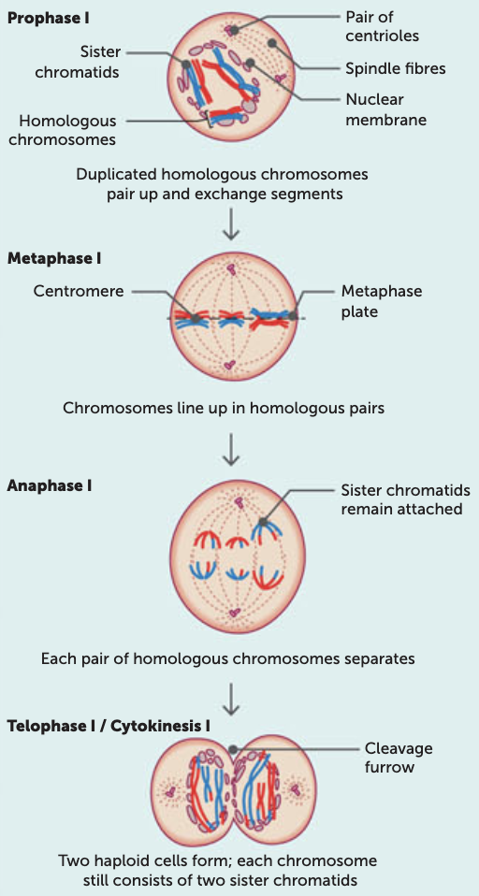 | 